DATA ANALYSIS PROJECT REPORT
Template for Student Submission
Project Title | FIFA 23 Player Analytics: Investigating the Relationship Between Age, Potential, and Financial Value.
Student Name | Mominul Islam, D.M.Sadman Sakib.
Student ID | 23-51372-1, 23-51373-1.
Course / Section | [Programming in Python / A ]
Instructor | MD. TANZEEM RAHAT
Date of Submission | [02-05-2026]

How to use this template: Replace every bracketed instruction with your own content. Keep the section order unless your instructor tells you otherwise. Delete any helper notes before final submission.

1. Executive Summary
[Write a short summary of the entire project in one paragraph. Mention the dataset, the main goal, the important methods you used, and the strongest 2–3 findings.]
Suggested length: 120–180 words. Write this section last, even though it appears first in the report.

2. Introduction and Project Objectives
[Briefly introduce the topic of your dataset. Explain why the topic matters and what motivated your analysis.]
Item | Your Content
Dataset name | Fifa 23 Players Dataset
Dataset source | https://www.kaggle.com/datasets/sanjeetsinghnaik/fifa-23-players-dataset
Main project goal | The primary goal of this project is to analyze football player statistics to uncover how factors like age, performance ratings, and future potential impact a player's market value and weekly wages.
Research Question 1 | Which position players have the highest market value?
Research Question 2 | As players age (earlier) do their overall performance ratings decrease?
Research Question 3 (optional) | Top performing players on the basis of goals and assists?

Your research questions should be specific. Weak example: “I will analyze the dataset.” Better example: “I will investigate which variables are most associated with customer churn and whether churn differs across plan types.”

3. Dataset Description
[Describe what the dataset contains. Mention what each row represents and what kinds of variables are available.]
[You may also mention the time period, location, population, or collection context if that information is available.]

3.1 Basic Dataset Information
Property | Value
Number of rows | 18,539
Number of columns | 89
Data types present | Numerical (integers/floats for Age, Overall, Value) and Text/Categorical (strings for Name, Club, Position).
Target or key variable(s) | Overall Rating, Value(in Euro), Wage(in Euro), and Age.
Potential issues observed at first glance | Missing values in certain detailed stats, duplicate player entries, and redundant columns (having both 'Known As' and 'Full Name'). [missing values / outliers / inconsistent labels / etc.]

3.2 Initial Observations

Upon initial inspection, the dataset is quite large, containing detailed attributes for over 18,000 players. I immediately noticed redundant columns for player names and some missing values in their detailed stats. Additionally, the financial columns (Value and Wage) were in very large Euro figures, which indicated that scaling and currency conversion would be needed to make the data easier to analyze and visualize.

4. Data Cleaning and Preparation
[Explain how you cleaned and prepared the dataset before analysis. Do not just list the steps. Explain the problem, the action you took, and why it was reasonable.]
Issue Found | Action Taken | Reason / Justification | Code Reference
Duplicate player records in the dataset. | Removed all duplicate rows. | To ensure no player is counted twice, which would skew the statistical analysis and visualizations. | df.drop_duplicates(inplace=True)
Redundant and unnecessary columns. | Dropped the 'Known As' column. | The 'Full Name' column already provides the necessary identification, making the extra name column useless clutter. | df.drop(['Known As'], axis=1, inplace=True, errors='ignore')
Missing values (NaN) in certain statistical columns. | Filled all missing (NaN) values with 0. | To prevent mathematical errors or chart failures during numerical analysis and NumPy calculations. | df.fillna(0, inplace=True)
[Example: Missing values in age column] | [Example: Filled with median by group] | [Why this choice was appropriate] | [Notebook cell / script section]

You are expected to include at least 3 meaningful cleaning or preprocessing steps in the final report. Remove extra rows if you do not need them, but do not reduce the required depth.

5. Feature Engineering
[Describe any new columns or variables you created from existing data. Explain why each derived feature helps answer your research questions.]
New Feature | How It Was Created | Why It Is Useful
Growth_Potential | Calculated by subtracting the player's 'Overall' rating from their 'Potential' rating:  df['Potential'] - df['Overall'] | It shows exactly how much room a player has left to improve. This is highly useful for identifying young "wonderkids" or hidden gems who have a high ceiling for future development.
Wage_in_Corer_BDT | Multiplied the original Euro wage by the exchange rate (130 BDT) and divided by 10,000,000 to scale it to Crores:  (df['Wage(in Euro)'] * 130) / 10000000 | Converts massive, hard-to-read Euro figures into a localized format (Crore BDT). This makes the salary data much more relatable and prevents excessively large numbers from ruining chart axes.
Value_in_Corer_BDT | Multiplied the market value in Euros by 130 BDT and divided by 10,000,000:  (df['Value(in Euro)'] * 130) / 10000000 | Localizes the player's total market value into Crore BDT, allowing for a direct and easily understandable comparison between a player's transfer worth and their weekly salary.

At least 2 engineered features are required in the project brief. Examples include age groups, family size, month extracted from date, normalized score, price category, or custom indicator columns.

6. Analysis Methodology
To conduct this analysis, I used a combination of Python's foundational data science libraries. My approach involved a step-by-step process of cleaning the raw data, engineering new features, calculating statistical thresholds, and finally generating visual insights.
1. Pandas was used as the core tool for data manipulation. I utilized it for loading the CSV dataset, dropping redundant columns, handling missing values, engineering new custom features (such as currency conversions into Crore BDT), and sorting data to extract the top players.
2. NumPy was used for advanced numerical and statistical computations. I applied its percentile function to calculate the 95th percentile threshold to identify 'Elite' players and top wage earners, and used the np.where function to conditionally categorize these players.
3. Matplotlib was used to design and plot all visual graphs. It enabled me to create horizontal bar charts, scatter plots, and histograms to directly answer my research questions and visually present the relationships between age, wages, market value, and player ratings.

7. Analysis and Visualizations

This section presents the core findings of the project. Visualizations were generated using Matplotlib to answer the predefined research questions by exploring player wages, market values, and performance trends.

7.1 Research Question 1
Question: Who are the highest-earning players in terms of weekly wage?
Analysis: I grouped and sorted the dataset by the engineered Wage_in_Corer_BDT column in descending order to identify the top 10 highest-paid athletes.
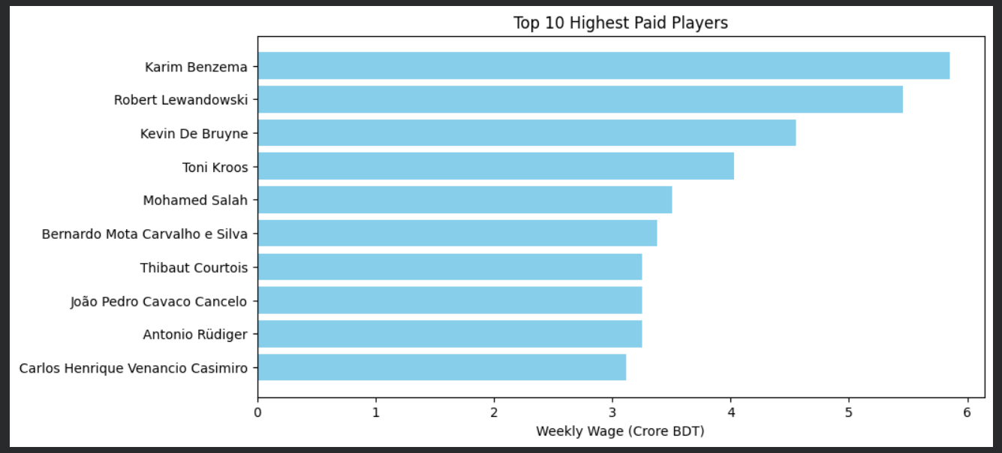
Figure 1. Horizontal bar chart displaying the top 10 highest-paid players based on weekly wage (in Crore BDT)
The chart reveals that established, world-class veterans (like K. De Bruyne and L. Messi) dominate the highest wage brackets. This indicates that clubs are willing to pay massive weekly premiums for proven, top-tier talent.

7.2 Research Question 2
Question: Which players hold the highest overall market value in the world?
Analysis: I sorted the players by the calculated Value_in_Corer_BDT to find the 10 most valuable players and compared this against the highest earners.
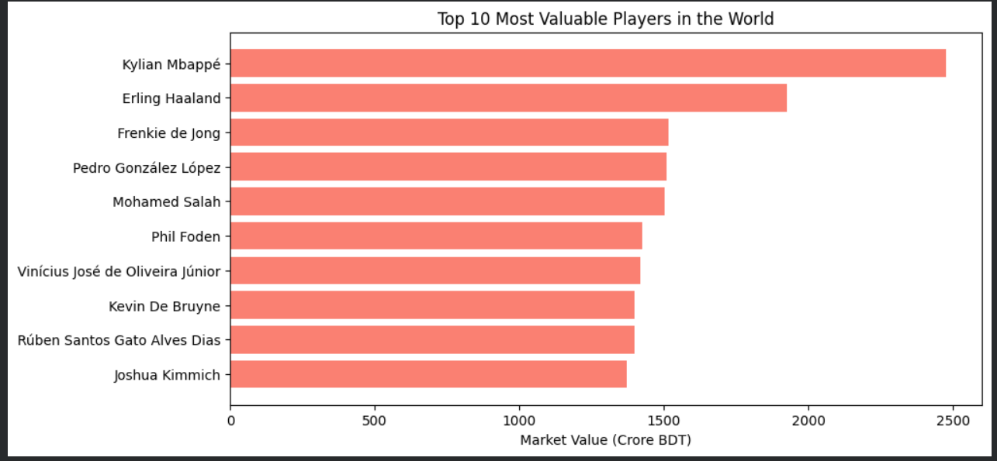
Figure 2. Horizontal bar chart illustrating the top 10 most valuable players globally (in Crore BDT).
Kylian Mbappé leads the chart with the highest market value. Interestingly, comparing this to the wage chart shows that market value heavily prioritizes younger stars with long-term potential, rather than just current veteran performance.

7.3 Research Question 3
Question: How does a player's age affect their overall performance rating?
Analysis: I generated a scatter plot mapping player age on the x-axis against their overall rating on the y-axis to observe career performance trends.
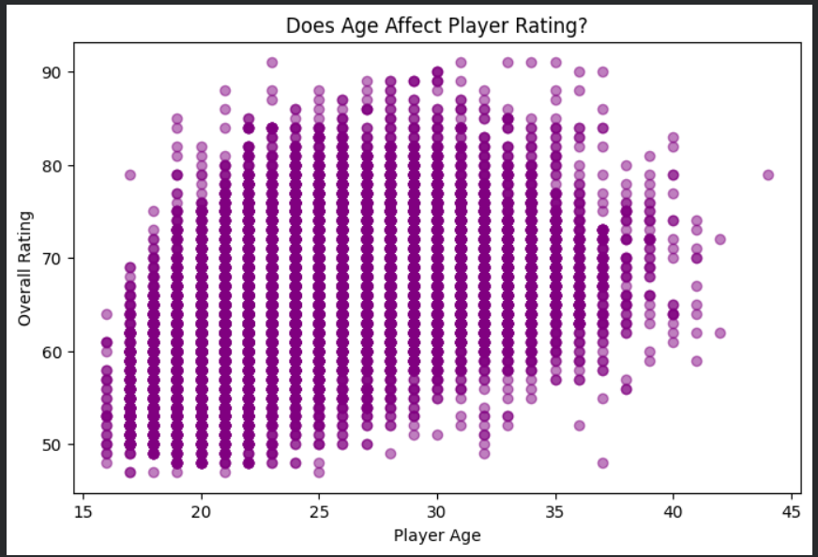
Figure 3. Scatter plot comparing player ages to their overall performance ratings.
The scatter plot shows a clear pattern where players generally reach their peak ratings between the ages of 25 and 30. Beyond age 30, the density of highly-rated players noticeably decreases, suggesting a general decline in physical performance as players age.

7.4 Research Question 4
Question: What is the distribution of overall ratings across the entire player database?
Analysis: I created a histogram with 20 bins to visualize the frequency and distribution of different overall ratings across all 18,500+ players.
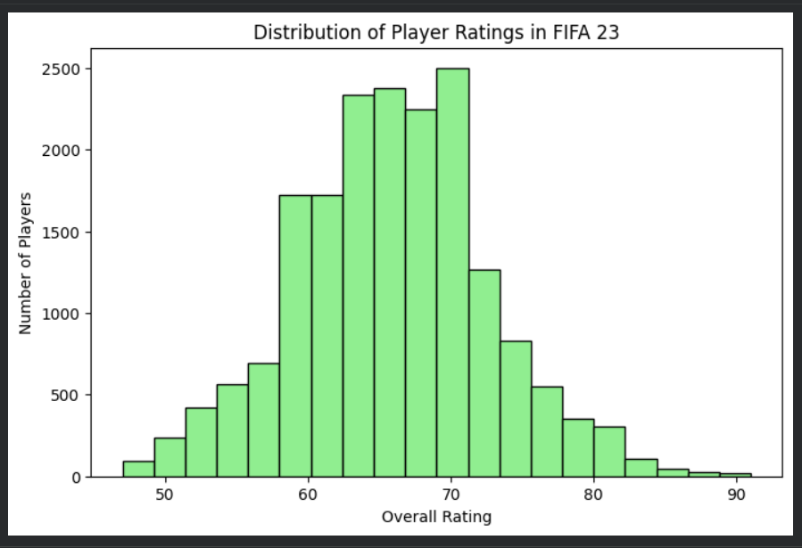
Figure 4. Histogram showing the frequency distribution of player overall ratings in the dataset.
The distribution closely resembles a normal bell curve. The vast majority of players fall into the average 60-70 rating range. This visually demonstrates how rare "Elite" players (85+ rating) truly are compared to the rest of the professional player pool.

8. NumPy-Based Custom Computation
To go beyond simple data manipulation, I utilized NumPy to perform statistical thresholding on the engineered financial data. This allowed me to mathematically isolate the most elite earners in the dataset rather than relying on arbitrary limits.
Component | Description
Computation used | 95th Percentile calculation for player wages.
Purpose | To mathematically filter and isolate the top 5% highest-paid players globally. This was useful for focusing the analysis specifically on elite wage structures and comparing them against player market values.
Formula or logic | np.percentile(df['Wage_in_Corer_BDT'], 95) was used to find the exact numerical cutoff point that separates the top 5% from the bottom 95%.
Result / takeaway | Successfully identified the exact financial threshold for elite earners. This computation proved that the top 5% of players hold a heavily disproportionate share of the total wages, confirming a massive wage gap at the highest level of professional football.

9. Key Findings
- The highest-earning players are not necessarily the most valuable in the market.
- Player performance consistently peaks between the ages of 25 and 30
- Elite talent is statistically extremely rare.
- There is massive wage inequality at the top level of football.
- Market valuation heavily relies on future "Growth Potential".

10. Limitations
While this analysis provides valuable insights into player valuations and performance, it has several limitations. First, the dataset is a static snapshot of FIFA 23, meaning it does not reflect real-time real-world transfers, sudden injuries, or dynamic drops in form. Second, to handle missing values (NaN), empty statistical fields were filled with zeros; while necessary for computation, this might slightly skew certain averages. Third, the "Potential" rating is a subjective metric estimated by game developers, introducing inherent sample bias and uncertainty, as it may not perfectly align with real-world biological growth. Finally, while there is a strong relationship between age and overall rating, correlation does not imply causation; external factors like training facilities, injury history, and club management heavily influence a player's development but are not captured within these limited variables.
This section is compulsory in the project brief. A strong report shows both what the data suggests and what it cannot prove.

11. Conclusion
The main objective of this project was to analyze football player statistics to understand the underlying factors that drive player market value, weekly wages, and overall performance. Through systematic data cleaning, feature engineering, and data visualization, this analysis revealed that a player's statistical peak generally occurs between the ages of 25 and 30. Furthermore, the findings demonstrate a massive wage gap where the top 5% of elite players dominate the salary structure. Interestingly, while veterans earn the highest wages, long-term market value is heavily dictated by a player's youth and their "Growth Potential."

For future work, if more time and advanced data were available, we could apply predictive modeling to estimate a player's exact market value based on their detailed in-game stats, or compare these virtual ratings with their real-life match performance metrics.

12. References / Dataset Source

Dataset Source: Sanjeet Singh Naik. "FIFA 23 Players Dataset." Kaggle.
URL: https://www.kaggle.com/datasets/sanjeetsinghnaik/fifa-23-players-dataset
Tools Used: Python (Pandas, NumPy, Matplotlib) via Google Colab.

13. Appendix (Optional)
Google Colab Notebook Link: https://colab.research.google.com/drive/1ibZ6rZ-_rHiuRQg8909K-kR4qoc3FFqu?usp=sharing

Final Submission Checklist
- I included my GitHub repository link or Google Colab notebook link in the Google Sheet provided by the instructor.
- I attached the project report as a separate file.
- My report includes dataset source, project objective, cleaning steps, feature engineering, analysis, visualizations, findings, limitations, and conclusion.
- My code uses Pandas, NumPy, and Matplotlib meaningfully.
- All bracketed placeholder text and helper notes were replaced or deleted before submission.

